1. **INTRODUCTION** 
   1. **Background**

The "Online Grocery Ordering System" has been developed to override the problems prevailing in the practicing manual system. This software is supported to eliminate and in some cases reduce the hardships faced by this existing system. Moreover this system is designed for the particular need of the company to carry out operations in a smooth and effective manner.

The application is reduced as much as possible to avoid errors while entering the data.

It also provides error message while entering invalid data. No formal knowledge is needed for the user to use this system. Thus by this all it proves it is user-friendly.Online Grocery Ordering System, as described above, can lead to error free, secure,reliable and fast management system. It can assist the user to concentrate on their other activities rather to concentrate on the record keeping. Thus it will help organization in better utilization of resources.

Every organization, whether big or small, has challenges to overcome and managing the information of Customer, Grocery, Stock, Address, Product. Every Online Grocery Ordering System has different Grocery needs, therefore we design exclusive employee management systems that are adapted to your managerial requirements. This is designed to assist in strategic planning, and will help you ensure that your organization is equipped with the right level of information and details for your future goals. Also, for those busy executive who are always on the go, our systems come with remote access features, which will allow you to manage your workforce anytime, at all times. These systems will ultimately allow you to better manage resources.

**1.2** **Necessity**

choosing what website to purchase groceries from.

**It saves time**

Shopping online alleviates the need to walk up and down store aisles. And you can log in any time—even at 2 am—and still have the advantage of a fully stocked store. Plus, going the delivery route saves you a trip to the store, which not only saves time, but gas money as well. In fact, studies show grocery delivery services slash carbon dioxide emissions in half compared to individual household trips.

**No Unwanted Luxury Purchases**

It’s far too easy to do; you’re walking around the shop grabbing all the items you need and suddenly a chocolate cake, packet of biscuits, and some sausage rolls have somehow found their way into your trolley. You didn’t want them before but now you’ve seen them you need them! Shopping online can help you tame the impulse buying within you.at one's fingertips, it can be considered as beneficial to the consumers. Let's have a look at some other benefits of buying vegetables and fruits online.

**1.3 Objectives**

Objective of Project on Online Grocery Ordering System:

The main objective of the Project on Online Grocery Ordering System is to manage the details of Grocery, Customer, Order, Stock, Product. It manages all the information about Grocery, Address, Product, Grocery. The project is totally built at administrative end and thus only the administrator is guaranteed the access. The purpose of the project is to build an application program to reduce the manual work for managing the Grocery. Customer, Address, Order. It tracks all the details about the Order, Stock, Product

* Provides the searching facilities based on various factors. Such as Grocery, Order, Stock. Product
* Online Grocery Ordering System also manage the Address details online for Stock details, Product details, Grocery.
* It tracks all the information of Customer, Address, StockManage the information of Customer
* Shows the information and description of the Grocery, Order
* To increase efficiency of managing the Grocery, Customer
* It deals with monitoring the information and transactions of Stoc
* Manage the information of Grocery
* Editing, adding and updating of Records is improved which results in proper
* resource management of Grocery data. • Manage the information of Stock
* Integration of all records of Product

**1.4 Theme**

Online grocery shopping allows consumers to purchase food without leaving home. Grocery shoppers have local, national, and international options available to them

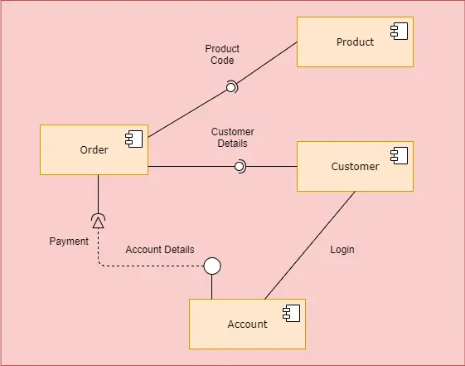

**1.4 User Interaction**

**2. LITERATURE REVIEW**

**2.1 Litreture Survey**

This chapter presents a review of the articles and business reports related to consumers’ grocery shopping decision making process, in both offline and online retail channels. The intent was to acquire a general overview of grocery shopping, in what pertains to this dissertation and subsequent research questions, and as such the focus relies mostly on the decisional phase and influencing pre-decisional phase of the grocery shopper decision making process. Based on the outcome of the literature review performed, a conceptual framework that guided the design and performance of the empirical studies, aiming at providing answers to the proposed research questions, is also presented

**2.1. The purchase decision making process in traditional retail environments**

A consumer purchase is typically a response to a problem or need, and once a consumer realizes this, he or she undergoes a series of steps until his or her need is satisfied (Solomon, Bamossy, Askegaard, & Hogg, 2006). This is a reflection of the consumer decision making process, which main stages are generally defined in the Consumer Behaviour and Marketing literature as: (1) Problem identification; (2) Information search; (3) Evaluation of alternatives; (4) Purchasing decision; (5) Post-purchase behaviour (e.g. Kotler & Keller, 2008; Solomon, Bamossy, Askegaard, & Hogg, 2006). However, not all decision making processes are exactly consistent with this model, as several external factors (such as consumer characteristics, motivations, socio-economic environment, etc.) may influence how consumers progress from one stage to the next (Solomon, Bamossy, Askegaard, & Hogg, 2006). In the context of the models of consumer decision making described by Solomom, Banossy, Askegaard, & Hogg (2006), grocery shopping can be best categorized as a habitual decision making process. As the decisions associated to most supermarket purchases typically demand only a low level of involvement from most consumers, being strongly related to the experience of past shopping trips and automated buying routines (Solomon, Bamossy, Askegaard, & Hogg, 2006). Nevertheless, supermarket product offers and grocery store environments are usually far more complex, information-rich and heterogeneous than those characterizing other types of purchases, encompassing a very large set of cues and stimuli designed to influence consumers’ decision making at the point of purchase. As 12 Inman, Ferraro & Winer (2004) established in their model for in-store decision making, customers are firstly exposed to product categories and in-store displays as they shop, with the intensity of exposure being highly influenced by several contextual factors, like shopping trip type, display type/location, number of aisles shopped and purchase involvement. Then, shoppers must be motivated to process the in-store stimuli to which they are exposed, a motivation which is in turn influenced by factors such as deal proneness, age and need for cognition. Next, the recognition of a need for the product category (if the consumer has not planned to purchase such category beforehand) must be acknowledged, something which again may be influenced by several factors, like compulsiveness, shopping party size, gender, household size, age and income. And finally, the actual decision execution must occur for each category purchase, independently of whether the purchase was planned beforehand or decided only inside the store

**2.2. The purchase decision making process in online retail environments**

When analysing the particular case of online shopping, factors other than those already reviewed come into play and should therefore be taken into account. Chen & Chang (2003) highlight three key quality dimensions that impact consumers’ satisfaction with online shopping activities and subsequent purchase: interactivity (e.g., the quality of broadband connection and the design of the website), transaction (e.g., shopping value, convenience, assurance, entertainment and evaluation) and fulfillment (e.g., order processing, delivery and post-sales service). Interactivity is closely linked to overall store satisfaction, as it can by itself demote or promote the consumer to continue browsing/searching/purchasing on a specific website. Meanwhile, the quality of the transaction process also plays a crucial role, as convenience, value and security are essential online consumer requirements. Finally, the level of fulfillment determines the confidence and trust consumers have in online transactions, and may also help to provide greater convenience and value to e-shoppers (Chen & Chang, 2003). Additionally, Constantinides (2004) reinforced the claim that, just as in traditional markets, the interaction of uncontrollable (consumer characteristics and environmental influences) and controllable factors (product/service characteristics, medium characteristics, merchant/intermediary characteristics) is also at play in the online shopping environment. Consequently, the controllable traditional marketing tactics, 13 which are essential to attract and engage consumers, are paired with the online shopping experience controllable elements as to provide a satisfactory consumer online experience (Constantinides, 2004). As such, online shopping experiences are viewed as being the outcome of website functionality, user characteristics, online cues and stimuli, information provisioning and product and service offers (Constantinides, 2004). All these factors will hence serve as input for buying decisions, alongside the traditional consumer decision making variables associated to offline purchasing. Finally, in their review of previous research, Darley, Blankson & Luethge (2010) present an online decision making process model, which further segregates the external influential factors into individual differences or characteristics (i.e., motives, values, lifestyle, and personality), socio-cultural factors (i.e., culture, social class, reference groups, and family), situational and economic factors, and online atmospherics or environmental aspects (i.e., website quality, interface, user satisfaction and user experience). This model is based on the central role occupied by traditional decision making processes in the online shopping environment, recognizing the existence of particular moderating and interacting effects. Furthermore, the authors highlight the satisfaction of human needs rather than emphasizing the specifics of the underlying technology, and emphasize online consumer behaviour as a complex phenomenon, with several links and interactions that are still unexplored and offer ground for further research.

**2.3. Grocery shopping in traditional stores**

As several studies indicate (e.g. Deloitte & Harrison Group, 2010; POPAI, 2011), grocery shoppers have begun to find ways to spend less and reduce risk in the mist of the current economic and financial crisis. They have learned new tactics to save money on supermarket purchases and manage their household pantry, while shopping trips have also become more careful and focused (Deloitte & Harrison Group, 2010). Consumers’ grocery shopping routine now regularly includes strategic and tactical features like clarifying wants versus needs, delaying gratification, lowering quality requirements, frequent channel, store and brand switching, an intense use of coupons, loyalty cards, shopping lists and other promotional offers, stockpiling and increasing purchase of private label products, among others (Deloitte & Harrison Group, 2010; POPAI, 2011). Furthermore, consumers are becoming increasingly less loyal to national 14 brands and also less likely to engage in impulse buying or new product trial, as the new aim for grocery shopping is household gratification while maintaining quality but minimizing expenditure (Deloitte & Harrison Group, 2010). Consumers are no longer afraid or ashamed to be seen shopping for a bargain, often viewing price as the single most important factor in choosing among retail brands and also a motive to patronize multiple stores, formats and retail brands (POPAI, 2011). Shoppers are also increasingly synergizing between the off- and on-line channels, in order to maximize the value of their purchases (POPAI, 2011; Deloitte & Harrison Group, 2010). To the same end, they are also becoming more receptive to new electronic shopping tools and savvier as to which fit better their purchase needs and plans, increasingly seeking all sorts of information resources available to gain more control over their shopping experience (POPAI, 2011). And while these new approaches and strategies are mostly based on cutting down expenditure, most consumers still do not feel like they are sacrificing much, and thus show no intention of returning to old shopping habits when the economy recovers (POPAI, 2011; Deloitte & Harrison Group, 2010). According to A.C. Nielsen’s annual report on consumer confidence (2010), Portuguese consumers are no exception to this scenario. As fellow shoppers worldwide, they are also changing their spending habits – e.g., eating out less, buying less garments and more private labels, being more concerned about energy and gas spending –, and show no intention of returning to old shopping habits.

**2.3.1. Pre-decisional stages**

How purchases are actually decided upon during shopping trips is greatly influenced not only by the purchase environment, but also by several pre-decisional factors. Namely, buying decisions are heavily conditioned by the goals consumers pursue within a specific purchase, which can be as diverse as satisfaction of general needs, acquisition of essential items, emotional gratification or mere entertainment (Santos, 2009). This reflects different shopping motivations, which shape shoppers’ decision making processes, and which can be generally distinguished as being of an utilitarian or hedonic perspective (Babin, Darden & Griffin, 1994; Cardoso & Pinto, 2010). Utilitarian shoppers are problem-solving, task-oriented consumers, who make mainly rational decisions. While, on the other hand, the hedonic shopper is often looking for enjoyment, emotional and/or sensory stimulation and the satisfaction of desires while carrying out 15 their shopping activities (Babin, Darden & Griffin, 1994; Cardoso & Pinto, 2010). In the context of grocery shopping, this activity can be, for some consumers, a highly stressful chore and nothing more than a hassle, rather than pleasant and enjoyable (Santos, 2009). In this sense, and given the habitual or routine characteristic of this type of purchase, which mostly focuses on the acquisition of essential items (Santos, 2009; Solomon, Bamossy, Askegaard, & Hogg, 2006), grocery shopping is mostly considered an activity with an underlying utilitarian motivation (Babin, Darden & Griffin, 1994; Cardoso & Pinto, 2010; Santos, 2009). Concurrently, the establishment and achievement of such shopping goals implies a series of pre-decisional steps, such as when to conduct a particular shopping trip, which stores to visit or which products to choose from (Santos, 2009). As Santos (2009) states, the timing of shopping trips is defined not only by the availability of the consumer, but also by the periods when the shopper believes to be more appropriate to visit the selected stores. While the decision of which stores to visit and which products to purchase is deeply influenced by the shopper’s expectations of which alternatives will better satisfy his or hers existing needs (Santos, 2009). Additionally, other pre-shopping decisional factors such as the use or not of a shopping list or shopping alone or accompanied, for example, are also likely to influence consumers’ behaviour and shopping outcomes (Santos, 2009; POPAI, 2011; Thomas & Garland, 2004). The use of a written shopping list, for instance, can act as an important shopping tool for goal achievement. As, for some, shopping lists yield the benefits of ensuring that needed products are acquired and hence minor fill-in shopping trips are avoided. While, for others, shopping lists mean fewer hassles, as the shopping process and budget expenditure are kept under control (Thomas & Garland, 2004; Santos, 2009). Furthermore, according to a study by the POPAI Institute (2011), unaccompanied shoppers are less likely to use written shopping lists and more likely to deviate more from their spending goals. While, accompanied shoppers tend to navigate more throughout the store, but see companions as having little influence on their purchases (POPAI, 2011). Indeed, grocery shopping patterns are heavily determined by consumer demand and subsequent shopping plans, and this has an important effect on the time and budget spent at the store (Santos, 2009).

**2.3.2. In-store buying decisions**

According to POPAI’s report on grocery shopper engagement (2012), the rate of overall in-store decision making (i.e., generally planned, unplanned and substitute purchases) has climbed to 76% in 2012, with most of this rise coming down to the increase of instore marketing activities. An increasingly important part of the marketing mix is, thus, the use of point-of-sales materials and devices to stimulate sales, given that the decision making process of shoppers is often triggered just at the sight of the product category displays or related in-store stimuli (e.g., POPAI, 2012; Inman, Winer & Ferraro, 2009; Park, Iyer & Smith, 1989). Therefore, planned purchases can be defined as purchase decisions completely established before entering the store, while unplanned or impulse purchases can be defined as made specifically inside the store, and thus dependent on the existing marketing activities (e.g., Inman, Winer & Ferraro, 2009). Consequently, positive affective reactions to in-store stimuli increase the likelihood of unplanned purchases, or, in other cases, prompt consumers to consider or remember that there is a need for a certain product category which was not considered at the time when the shopping plans were made (Inman, Winer & Ferraro, 2009). Concurrently with the interaction of the shopper and the shopping environment, consumer’s proneness to unplanned purchases has also been shown to vary with out-of-store stimuli, such as overall shopping goals (Bell, Corsten & Knox, 2011). In this sense, research has shown that on major shopping trips there is a higher incidence of unplanned purchases rather than on fill-in trips, given that in-store stimuli are likely to have a higher impact on more broadly-defined purchase intentions (Kollat & Willett, 1967; Bell, Corsten & Knox, 2011). Also, consumers on major shopping trips are likely to spend more time inside the grocery store and therefore become more exposed to in-store stimuli (Kollat & Willett, 1967; Bell, Corsten & Knox, 2011). Moreover, Park, Iyer & Smith (1989) have found that time restrictions and high store familiarity limit the extent to which shoppers process in-store information, and as such, shoppers make more unplanned purchases under no time pressure and in unfamiliar stores. Additionally, Bell, Corsten & Knox, (2011) have found that on trips in which the household chooses the store based on its low prices there is more unplanned buying, as the consumer may feel its extra purchases to be justifiable. Moreover, the authors suggest that on trips in which the household chooses the store as part of a multi-store shopping strategy there are less unplanned purchases, as this reflects a strategy of more specifically-defined goals. Another important aspect of unplanned purchases was stated by Stilley, Inman & 17 Wakefield (2010), which argue that consumers anticipate the occurrence of unplanned purchases because they realize they have neither the time nor the resources to fully plan, and/or because they want to be able to make spontaneous decisions while in-store. Therefore, these authors defend that consumers establish a mental budget to spend on a specific grocery shopping trip and that this budget includes room for impulse purchases. Additionally, even when a budget is not explicitly defined, consumers will know by experience the average amount to spend due to the routinized nature of grocery shopping, and will take this into account (Stilley, Inman & Wakefield, 2010)

**2.4. Grocery shopping in online stores**

Online grocery stores were amongst the first Internet start-ups to be launched in the late 1990’s. Nevertheless, it was only very late that this type of business was able to gain enough traction amongst North-American and European consumers, currently accounting for only a small portion of total online retail sales in many countries (KPMG International, 2012; Lim, Widdows & Hooker, 2009; Ramus & Nielsen, 2005). Nevertheless, after books, clothing and other product categories, grocery shopping is emerging as the next fastest growing category in online retailing (KPMG International, 2012). As such, the strong predicted growth of the online grocery channel in Western countries presents good business opportunities for brand manufacturers and retailers alike (Lim, Widdows & Hooker, 2009). A study by KPMG International (2012) has encountered that, in such developed countries, the largest segment of online grocery shoppers is mainly composed of highly educated (graduates or above) females, aged 25–55 years old, with a full or a part-time job and with children under their care. Due to the current economic conditions, however, this study found that more consumers from all income levels are beginning to buy groceries online, looking to benefit from the variety of promotional offers that tend to be exclusive to this retail format. Additionally, the KPMG International (2012) study uncovered that consumers are gradually shifting from personal computers to mobile phone and tablets as the preferred device for online shopping. Consequently, the continued development of mobile applications and its increased convenience of use and associated services should help increase even more the occurrence of online grocery shopping (KPMG International, 2012). Moreover, the referred study defends that online grocery stores offer the contemporary, time and money tight customers a way to conveniently search and acquire products, alongside 18 with the opportunity to more easily control their budget and closely monitor their cart contents (KPMG International, 2012). Thus, the aspect that seems to be, at least, one of the main drivers for online shoppers is the need for convenient shopping activities (e.g., Rohm and Swaminathan’s, 2004; Morganosky & Cude, 2000; Ramus & Nielsen, 2005; Verhoef & Langerak, 2001; Robinson, Riley, Reetie & Rolls-Willson, 2007). The study performed by Rohm & Swaminatham (2004), for instance, confirms this result arguing that convenience, paired with variety seeking, are the main underlying motivations in the online channel, while time savings and recreational shopping orientations appear to be more significant drivers in the offline store format. Although convenience remains important in both retail channels, one possible explanation the authors found for the differentiating drivers between store formats may be that, while there is time saved in shopping online, there is also a higher time gap between purchase and actual acquisition of the goods purchased, due to the delivery waiting periods.

**2.4.1. Adoption and buying motivations**

“Digital retailing is playing an increasingly pivotal role in the way consumers shop, having changed their expectations and preferences considerably” (KPMG International, 2012). This development also applies to the online grocery store business, as a study undertaken by Hansen (2005) indicates that, on average, consumers are now well familiar with online grocery stores and do not associate a particularly higher risk of shopping online for grocery products, when compared to other product categories. Yet, there are still some strong barriers to widespread online grocery shopping adoption, namely consumer skepticism and uncertainty, the payment of delivery fees, the occurrence of delayed and/or wrong deliveries, a lack of/lower level of online promotional activities, a higher task complexity and insufficiently user-friendly websites (Robinson, Riley, Reetie & Rolls-Willson, 2007; KPMG International, 2012). These perceived drawbacks lower the trust of potential customers on online transactions, decrease conversion rates from browsers to shoppers, reduce basket sizes and limit the number of returning customers (KPMG International, 2012). Additionally, it is suspected that consumers continue to shop for groceries offline out of habit, or due to a lack of awareness and actual availability of online options (Nielsen, 2009). These are unfortunate circumstances, as more consumers increasingly appreciate the opportunity to shop day and night for groceries and avoid the unpleasant experiences 19 that can accompany shopping in traditional stores, such as crowds or traffic (Nielsen, 2009; Robinson, Riley, Reetie & Rolls-Willson, 2007; Morganosky & Cude, 2000). Furthermore, online grocery shopping allows consumers to buy in bulk and stock up without having to lug around heavy packages (Nielsen, 2009; Robinson, Riley, Reetie & Rolls-Willson, 2007). Finally, it helps time-restricted consumers to save time and money, and can become a less stressful way of shopping, one in which consumers exercise greater control over their purchases and better compare products and offers (KPMG International, 2012; Nielsen, 2009; Verhoef & Langerak, 2001). As such, more evidence is provided which denotes shopping convenience as one of the main drivers for online grocery shopping (e.g., Nielsen, 2009; Verhoef & Langerak, 2001). Accordingly, Robinson, Riley, Reetie & Rolls-Willson (2007), supporting earlier findings by Morganosky & Cude (2000), noted that convenience seems particularly relevant when some situational constraints - such as ill health, changing homes or jobs, breaking a limb, having a baby, working late, children leaving home, working from home, aging, etc. – come into play. In addition, the authors argue that the disappearance of such situational constraints is also often the primary reason for stopping or diminishing the frequency of online grocery shopping. In this sense, online grocery shopping has been found to be, by several studies, highly discretionary (Hand, Riley, Harris, Singh & Rettie, 2009; Robinson, Riley, Reetie & Rolls-Willson, 2007; Morganosky & Cude, 2000), as it may be forsaken when a specific trigger disappears or when, for some reason, consumers become unhappy with the level of service. This indicates that even the high demand for convenience that often drives the adoption of online grocery shopping may be highly contingent upon particular individual circumstances (Hand, Riley, Harris, Singh & Rettie, 2009). This leads to the frequent re-evaluation of the decision to conduct grocery shopping in online formats. Consequently, post-adoption evaluations become particularly crucial to the decision of whether or not to continue using an online grocery store (Hand, Riley, Harris, Singh & Rettie, 2009). Taken together, past findings suggest that online grocery shopping is complementary to, rather than a substitute of, traditional grocery shopping (Hand, Riley, Harris, Singh & Rettie, 2009; Robinson, Riley, Reetie & Rolls-Willson, 2007; Morganosky & Cude, 2000). As evidence has been found that most consumers shop personally, at least, for perishables and/or special products (i.e., items shopped with an uncommon purpose, as for example a dinner party) (Robinson, Riley, Reetie & RollsWillson, 2007; Morganosky & Cude, 2000). 20

**2.4.2. Buying, browsing and search patterns**

Some studies have investigated consumers’ search and browsing patterns for several product categories, within the online environment (e.g. Moe, 2003; Wolfinbarger & Gilly, 2001). In a research by Moe (2003), for example, a distinction between goaldirected search and exploratory search is made. On one hand, exploratory search is less deliberate and focused on a particular purchase occasion. It tends to be more undirected and stimulus-driven than goal-driven, hence being often referred to as browsing or ongoing search, and in many instances derives from consumers’ poor familiarity with product categories. Goal-directed search, on the other hand, refers to situations in which online consumers browse the web with a specific or planned purchase in mind. In this case, search patterns are very focused and driven towards goal achievement. As a result, goal-directed searches are highly task-oriented, rational, efficient and deliberate (Moe, 2003; Wolfinbarger & Gilly, 2001). Furthermore, goal-oriented consumers reach control, freedom and lack of commitment in the online channel, as they encounter little pressure to purchase before they are completely ready, and are thus found to be less impulsive (Wolfinbarger & Gilly, 2001). Additionally, and as previously mentioned, online grocery shopping, as offline grocery shopping, is considered by most consumers as a chore, an activity which is performed mainly by utilitarian, rather than hedonic, shopping motivations (Robinson, Riley, Reetie & Rolls-Willson, 2007; Verhoef & Langerak, 2001), and which is highly directed towards goal achievement (POPAI, 2012). Thus, online grocery store visits should be considered as directed-buying internet visits, which are more likely to result in immediate purchases (Moe, 2003). A typical characteristic of such directed-buying visits is the consumer’s tendency to present focused search patterns, which represent the shopper’s goal-driven motivation (Moe, 2003). This, however, does not totally exclude the possibility of exploratory search behaviours at the category, product or even brand level and hence does not necessarily preclude the incidence of in-store decision-making, depending also on the extent and nature of the encountered stimuli (Moe, 2003). In regards to online stimuli, a study conducted by Parsons & Conroy (2006) suggests that grocery websites provide examples of the middle ground concerning the relationship between stimuli and the browsing experience. Given that online grocery stores are more likely to have frequent repeat visits, consumers should be more pervious to familiar stimuli and would not want to become over-stimulated, relatively to what happens in traditional stores (Parsons & Conroy, 2006). In addition, the referred study uncovered that, online grocery shoppers 21 have a preference for fast tempo, low volume music and average pitch, and that the matching of these requirements would likely increase the time spent browsing the store.

**2.5. conceptual framework**

The literature reviewed allowed for the understanding of the main characteristics of both offline and online grocery shopping, setting a framework of the most important factors influencing the consumer’s online decision making process. While establishing a baseline for online grocery shopping, as to support this dissertation in its quality of exploratory study and in what relates to the problem statement and research questions defined. Figure 2.2, shows the conceptual framework designed to guide the elaboration of the field study.

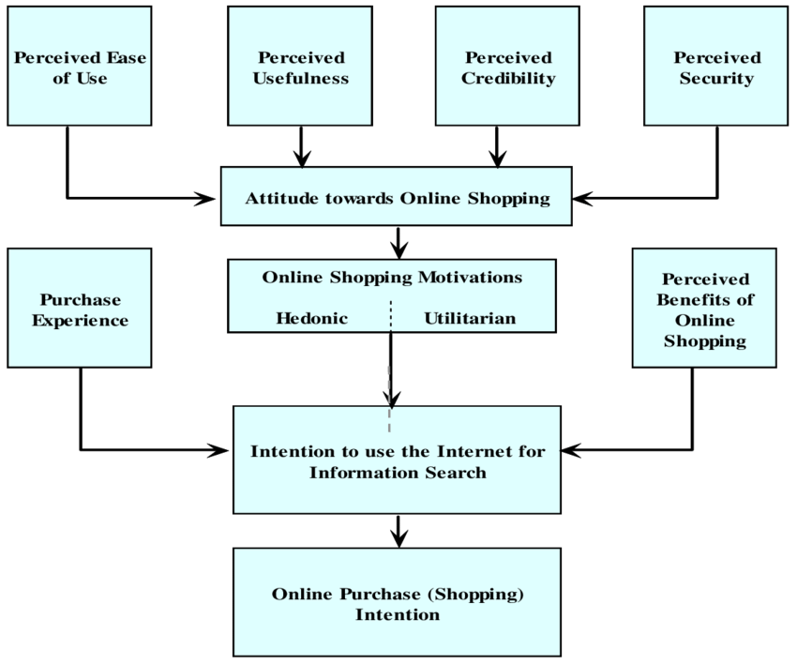

**2.5 Conceptual Framework**

* **CHAPTER 3: Equipments required**

**Software’s used in this Project**

Operating System : Windows XP/7/8/8.1 or Linux

User Interface : HTML, CSS

Server-side Scripting : PHP Script

Client-side-Scripting : Java Script

Programming Languag : PHP

Web Applications : Xamp Server

Database : MySQL

Server Deployment : Apache

Any Browser like chorme,firefox,etc

**Minimum Hardware requirement:**

Processor : Intel Pentium 4

RAM : 512 MB

Hard Disk : 2 GB

**4. SYSTEM DEVELOPMENT**

**4.1 Construction**

**Step #1. Start With A Domain Name**

A domain name is a virtual address of an online store or website.

Example: https://www.onlinegrocerystore.com

Ideally, a domain name should be:

* Having a .com extension
* Short in length
* Easy to pronounce
* Available (not already taken by someone else)
* Having a meaning related to grocery
* SEO-friendly

You need to buy a domain name from a domain registrar. It’s simple process. Just like buying any other digital product. Add the domain name you want to the cart, select the validity, enter your address & then checkout.I’ve bought all my domain names (including Bizain) from NameCheap. Their easy-to-use dashboard & support is what I like the most.

**Step #2. Create The Online Grocery eCommerce Store**

Once you’ve your domain name ready, time to create an online grocery store.

The best way to do that is by using an eCommerce website builder. An eCommerce website builder can help you to build an online grocery store within a matter of minutes. No, you need not know coding or programming skills.Most popular eCommerce builders have drag-and-drop editor as one of the core features. That means you can build a website simply by dragging & dropping various web elements like text, images, videos, menus etc.

Typically, an eCommerce store builder can help you build a grocery store by the following simple methods:

* Create an account
* Connect your domain name
* Choose & install website template or theme (that’ll define the structure & look of your website)
* Edit the website template to suit your needs
* Feed the website content (Title, description & images)

**4.1.1 Frame**

**4.2 Working**

How does online grocery shopping work?

Each store has its own different ways of delivery and order process but in most of the cases, you need an email or any social media to log into your account. By logging in into the website you can see the past orders and cart items. You can choose groceries or products from 22,000+ products and food items and get them delivered to your doorsteps.All you have to do is choose your product and place the order. And then wait for your order to reach you in less than 2 hours. This way it saves your energy, time and money.

Our age is subjected to innovation for nearly everything. At that point why grocery shopping ought to be abandoned? To be completely honest, a couple of years back, the main trip for busy workers used to be a supermarket for grocery shopping .The long billing queues made it most exceedingly terrible. With time, innovation flipped the coin and made a huge difference for good. thanks to E-Commerce for making online stores for selling food products. It spares both time and effort.

The current **COVID-19 pandemic** nationwide is a kickstarter to all those thinkers who wish to start up their e-commerce. The situation doesn’t allow large gatherings and has even shut down the shops and malls. The scenario where people are not required to access the services offline and even not to step out of their houses, e-commerce has a way out of delivering all the essentials at your doorstep. So, planning to have an e-grocery shop? Right time is here!

The online market business is booming in India, on account of an ever-expanding number of individuals settling on the accommodation of using their cell phones to buy their food supplies online. Online grocery business is expected to grow at a rate of 25-30% per year in majority of the cities in India and is expected to cross $25 billion by the year 2020.

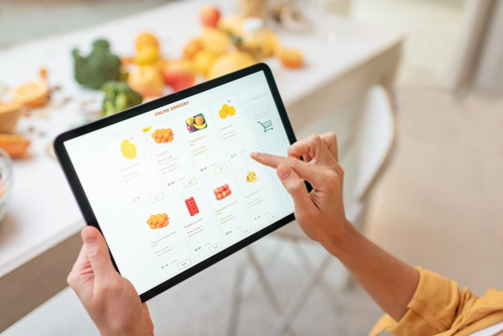

**4.2 Working Concept**

There is no preferable time over at this point! Try not to keep yourself down, it's simple to sell food products/ groceries online. So how does an individual approach setting up his/her online grocery business in India? Let me give you a bit by bit manual for arranging your online shop.

**IDENTIFY AND DECIDE THE TARGET AUDIENCE/ MARKET**

Food products, vegetables, milk, pulses and other basic food item staples being perishable goods have a constrained time frame of usability and a little delivery range –if they are to be delivered fresh.

Henceforth you have to design your delivery outskirts as needs be, to guarantee that the goods demanded by your clients can be delivered rapidly while keeping up the greatest measures.

Recognizing the dietary patterns and purchasing behaviors of the individuals who remain in the specific zone is likewise significant.

It will empower you to recognize which things sell quicker and spot rising trends well in advance thereby permitting you to stock fast moving items in advance and limiting the opportunity of wastage.

**SET UP OF A WAREHOUSE/ OFFICE**

Since you have your area and potential clients mapped out you may require a distribution center to store the items/produce which you will sell online.

Decide on a space situated inside your region or as close as could be expected under the circumstances – to guarantee prompt delivery of goods to waiting customers.

On the other hand you can distinguish, start a tie-up or partnership plan with dependable suppliers and wholesalers. They can keep you well supplied with all the items and things you need all the time.

Since you will purchase a bulk of the goods and all the time, you can easily negotiate the rates and request a volume discount.

**REGISTRATION OF AN ONLINE BUSINESS**

This is an essential advance in the entire procedure of setting up your own online supermarket.

In case you're an individual, you can register your organization as a proprietary concern, or settle on a partnership registration in case you have partners.

You can take the assistance of any recognised tax advisor or chartered accountant to assist you with finishing the registration and pertinent GST conventions.

When your registrations formalities are finished, you would then be able to start a business account at any bank of your decision.

**SETTING UP OF A STRONG DELIVERY SYSTEM**

The achievement of an online staple business depends intensely on how quick you can deliver the things to your client's home/office.

This makes setting up an effective delivery framework a basic factor in the whole beginning up process.

In India most clients incline towards the same day delivery – all the more so on account of food and basic food item things – and any delay in this specific portion is generally disapproved of.

Anyways this is exclusively not possible because of an absence of HR or the inaccessibility of vehicles to ship the merchandise.

Deliveries likewise will in general come at an immense expense to the organization, representing about 30-40% of the general costs of doing business.

So what is the best alternative to adopt under these conditions?

if your delivery range is inside 5-8 km from your base of activities, your most solid option is to use delivery young men with the bikes.

Indeed, it's a similar model followed by a large group of famous pizza delivery chains as well. Its' quick (given the terrible traffic conditions during peak hours), typically trustworthy and turns out to be very sensible as far as the expense and fuel costs.

To be fruitful an online basic food item business needs to depend vigorously on the effectiveness of its home delivery framework.

Confirming a request and afterward not being in a situation to deliver it to the client around the same time can do irreparable harm to your online groceries startup – so it's ideal to maintain a strategic distance from such traps if you can.

**START AN ONLINE GROCERY WEBSITE**

Creating an e-commerce website is a major step to set-up your online grocery store. You have two options to proceed with this one. You can either go for the conventional site making the process that will be lengthy and costly. Or you can make a smart move and partner up with an expert e-commerce service provider to save time and money. Ensure you are a part of the whole procedure directly from ideating about the web composition, finishing the substance to picking the best internet business format for your basic food item site. From a customer convenience point of view, besides, rushing to load, easy to use and mobile friendly, a smart and proficient basic grocery website can likewise emphasise on a few additional features. Consider making a mobile application for both android and IOS devices for ease and better reach.

**MODE OF PAYMENT**

With regards to payments, clients search for numerous alternatives for mode of payment. Some are fine with payments through their cards while others favour payment wallets to profit cash-back offers. Search for a stage that gives an adaptable yet reliable payment solution. Ensure your grocery market can incorporate your website with online payment wallets and payment gateway. You can even give the option of cash on delivery to your customers to pay when the delivery boy delivers the groceries. Bharat UPI provides a reliable platform for e-commerce to receive payments online via the platform giving an instant payout. If you too are in e-commerce, consider switching to Bharat UPI and receive payouts faster. You can get the money in just 1 sec in your account with 0% transaction charges

**MAKE A EFFICIENT MARKETING PLAN**

Your online grocery store needs strong marketing in the event that you need to make it effective. Your store's online presence must be felt by your targeted audience. You can go for on-page and off-page SEO of your site. Ensure you likewise use offline marketing techniques like dispersing flyers banners and coupon pamphlets at nearby places. discount and offers are the most tried and used technique for marketing. Go for an e commerce business partner that has a committed marketing based module for your grocery store. This will assist you with overseeing substantial traffic in a sorted way. You can even switch to putting an advertisement in the newspaper, sending a SMS or by putting up hoardings in and around.

The present quick paced way of life, tiring drives and long working hours are among the key elements liable for causing an increasing number of individuals to decide to shop online.

Online shopping for groceries obviously offers a helpful choice for such clients by sparing them both the time and the physical exertion expected to search for staple goods.

These online websites can also be paid by the buyers via United Payments Interface (UPI) which reduces the effort of filling all the bank details again or writing up a cheque frequently. Using Bharat UPI has made it easier to transfer money for any online transaction.

**Pros:**

* You can get more offers and discounts when compared to offline shopping.
* Online grocery shopping saves your time and money.
* You can add items to your cart the whole week and buy them at once.
* It is less stressful and makes the shopping process easier when compared to offline shopping.
* It is environmentally friendly and reduces pollution.

**Cons:**

Sometimes the cost can be more depending upon the store and season, including delivery fees.

As you can’t handpick each item, sometimes the quality of the products or food items can be challenging.

* User-Friendliness. eCommerce sites must be easy to navigate. ...
* Brand Identity. Ensure that your brand is prominently displayed throughout the website. ...
* Trust and Security. ...
* Searchability. ...
* Product Descriptions. ...
* Minimalistic Approach. ...
* Calls to Action. ...
* Customer Reviews.

**4.3 Principle**

#### **User-Friendliness**

eCommerce sites must be easy to navigate. One way to accomplish that is to group your products under specific categories with a menu at the top that shows all those categories.

* **Brand Identity**

Ensure that your brand is prominently displayed throughout the website. Choose colors that reflect the brand and set a clear style representing your products. To foster a strong brand-customer relationship, ensure that the brand experience is consistent across all channels, whether online, in-store, or mobile.

#### **Trust and Security**

Design a site that shoppers can trust because privacy is paramount, i.e., ensure that transactions are secure and that personal data is protected. If shoppers feel your site is not trustworthy, they will shop elsewhere. Also, your payment gateway directly affects revenue; ensure that it’s safe and secure.

#### **Searchability**

A clearly visible search field must be within reach at all times. That way, your visitors can quickly find what they’re looking for without having to navigate multiple times. This feature is particularly attractive to those who already know what products they are interested in.

#### **Product Descriptions**

Product descriptions on your site are crucial and can greatly influence purchasing decisions. The more alluring the fonts, the descriptions, the images, and the videos are, the better visitors can relate to their buying needs. Even though product descriptions are not part of the design, paying attention to them can definitely increase your ROI in the long run.

#### **Minimalistic Approach**

Typically, eCommerce sites carry a lot of content and visitors must plow through numerous products and related information to pinpoint what they are after. A fancy design would only complicate the picture.

Therefore, opt for a minimalistic design with neutral colors, such as a white background. Minimalism is not simplism, however; your website must still reflect professionalism and polish in brand and design.

#### **Calls to Action**

Given that the ultimate goal of your site is to attract customers and generate revenue, calls to action play a vital role there. Make the CTAs as short and clear as possible to align with your visitors’ behavior, some of whom are probably browsing and making purchase decisions quickly.

#### **Customer Reviews**

Customer reviews are one of the first things people look at before deciding whether to buy a product. Ensure that the reviews on your products are easy to find and follow. Since people spend a lot of time reading them, make that an enjoyable thing to do, for example, by featuring starred ratings, displaying reviews in an easily readable font, and presenting an average score for the products.

#### **Optimization for Mobile**

The mobile version of eCommerce sites must have the same effect on visitors as their desktop version. However, given the smaller screen size on mobile, it’s challenging to bring over the same look and feel and messaging from desktop to mobile and to keep visitors interested and aware of all the purchase options. So, be sure to give your mobile eCommerce site ample attention and adjust its design for usability.

**4.4 Technical Specifications**

**Front-end technologies:** The website should be built using modern front-end technologies such as HTML5, CSS3, JavaScript, and jQuery. These technologies provide the foundation for the website's user interface and design.

**Back-end technologies:** The website should be built using a robust back-end technology such as PHP,.js. The back-end technology will handle the website's data management, authentication, and server-side processing.

**Database**: The website should use a database to store information such as user data, product information, and order history. The database should be reliable, secure, and scalable.

**Shopping cart:** The website should include a shopping cart that allows customers to add products to their cart and checkout when they are ready to make a purchase. The shopping cart should be easy to use, intuitive, and support multiple payment and shipping options.

**User management:** The website should include a user management system that allows customers to create accounts, manage their profile information, view their order history, and track their deliveries.

**Security**: The website should be designed with security in mind and should include features such as SSL encryption, secure user authentication, and protection against SQL injection and cross-site scripting attacks.

**Mobile responsiveness**: The website should be designed to be mobile-friendly and responsive to different screen sizes and devices.

**Scalability**: The website should be built with scalability in mind to handle large volumes of traffic, product inventory, and customer data as the business grows.

**Analytics**: The website should include analytics tools that provide insights into website traffic, user behavior, and sales performance. These insights can help improve the website's performance and user experience.

Overall, the technical specification for a grocery website should be designed to provide a robust, secure, and user-friendly online shopping experience for customers while also supporting the needs of the business in terms of data management, scalability, and analytics.

**4.5 Design Specifications**

**Layout and Navigation:** The website should have a clear and easy-to-navigate layout, with intuitive menus and search functionality to help customers find products quickly. The website should also be designed to be mobile-friendly, responsive to different screen sizes and devices.

**Color Scheme and Typography:** The website's color scheme and typography should be chosen to create a clean, professional, and visually appealing design. The colors used should be harmonious and appropriate for the grocery industry, with clear contrast between text and background.

**Product Display:** The website should have a clear and visually appealing way to display products, with high-quality product images, detailed descriptions, and relevant information such as prices, product reviews, and nutritional information.

**Shopping Cart and Checkout Process:** The website should have a clear and easy-to-use shopping cart, with options to add, remove, and update items. The checkout process should be straightforward and easy to follow, with clear steps, secure payment options, and delivery options.

**User Experience and Interface:** The website should be designed to provide an excellent user experience, with clear calls-to-action, intuitive user interface, and responsive design. The website should also have features such as customer reviews, product recommendations, and personalized offers to enhance the customer experience.

**Branding:** The website design should reflect the grocery store's brand identity, with appropriate use of logos, color schemes, and typography. The website should also be designed to build customer trust, with clear messaging and a professional, credible design.

**Accessibility**: The website design should be accessible to all users, including those with disabilities. The website should be designed to comply with WCAG 2.1 guidelines, with clear labeling, keyboard navigation, and alternative text for images.

**Performance:** The website design should be optimized for fast loading times and smooth performance. The website should be designed to minimize load times and improve performance, with efficient coding, optimized images, and use of caching.

Overall, a design specification for a grocery website should be designed to provide a visually appealing, user-friendly, and accessible online shopping experience for customers, while also reflecting the store's brand identity and meeting technical requirements for performance and functionality.

**4.6 Observations**

Following table shows the observations shows the details readind of motor and voltage which obtained directly from motor indicator**.**

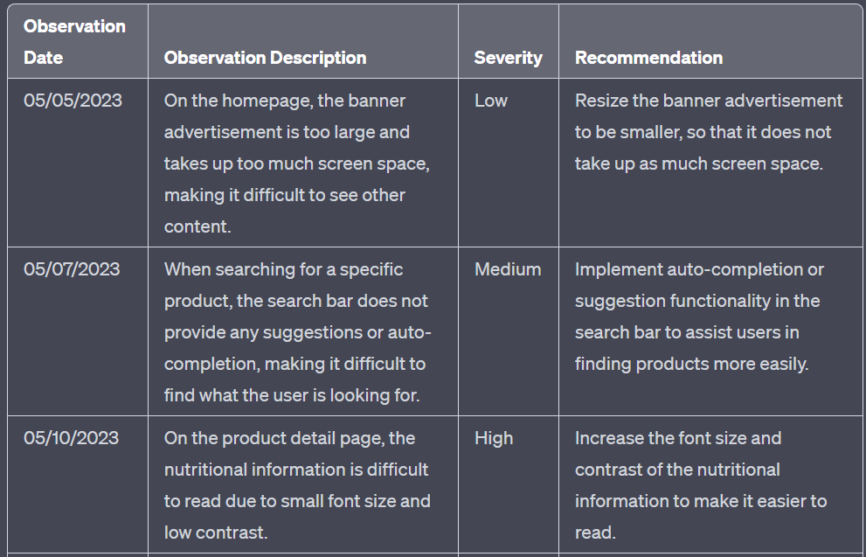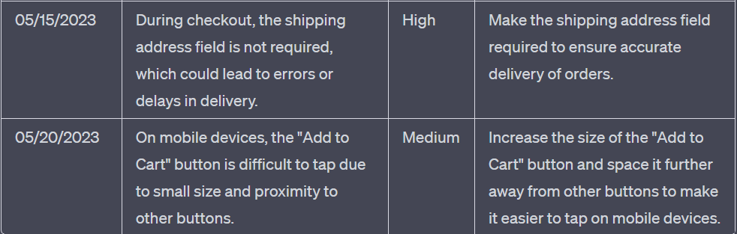

**3.6 Observation Table**

**7. PERFORMANCE ANALYSIS**

**7.1 Parameter Performance**

**Layout and Navigation:** The website should have a clear and easy-to-navigate layout, with intuitive menus and search functionality to help customers find products quickly. The website should also be designed to be mobile-friendly, responsive to different screen sizes and devices.

**Color Scheme and Typography**: The website's color scheme and typography should be chosen to create a clean, professional, and visually appealing design. The colors used should be harmonious and appropriate for the grocery industry, with clear contrast between text and background.

**Product Display**: The website should have a clear and visually appealing way to display products, with high-quality product images, detailed descriptions, and relevant information such as prices, product reviews, and nutritional information.

**Shopping Cart and Checkout Process**: The website should have a clear and easy-to-use shopping cart, with options to add, remove, and update items. The checkout process should be straightforward and easy to follow, with clear steps, secure payment options, and delivery options.

**User Experience and Interface**: The website should be designed to provide an excellent user experience, with clear calls-to-action, intuitive user interface, and responsive design. The website should also have features such as customer reviews, product recommendations, and personalized offers to enhance the customer experience.

**Branding:** The website design should reflect the grocery store's brand identity, with appropriate use of logos, color schemes, and typography. The website should also be designed to build customer trust, with clear messaging and a professional, credible design.

**Accessibility:** The website design should be accessible to all users, including those with disabilities. The website should be designed to comply with WCAG 2.1 guidelines, with clear labeling, keyboard navigation, and alternative text for images.

**Performance:** The website design should be optimized for fast loading times and smooth performance. The website should be designed to minimize load times and improve performance, with efficient coding, optimized images, and use of caching.

**4.1.1 Graphical Comparison**

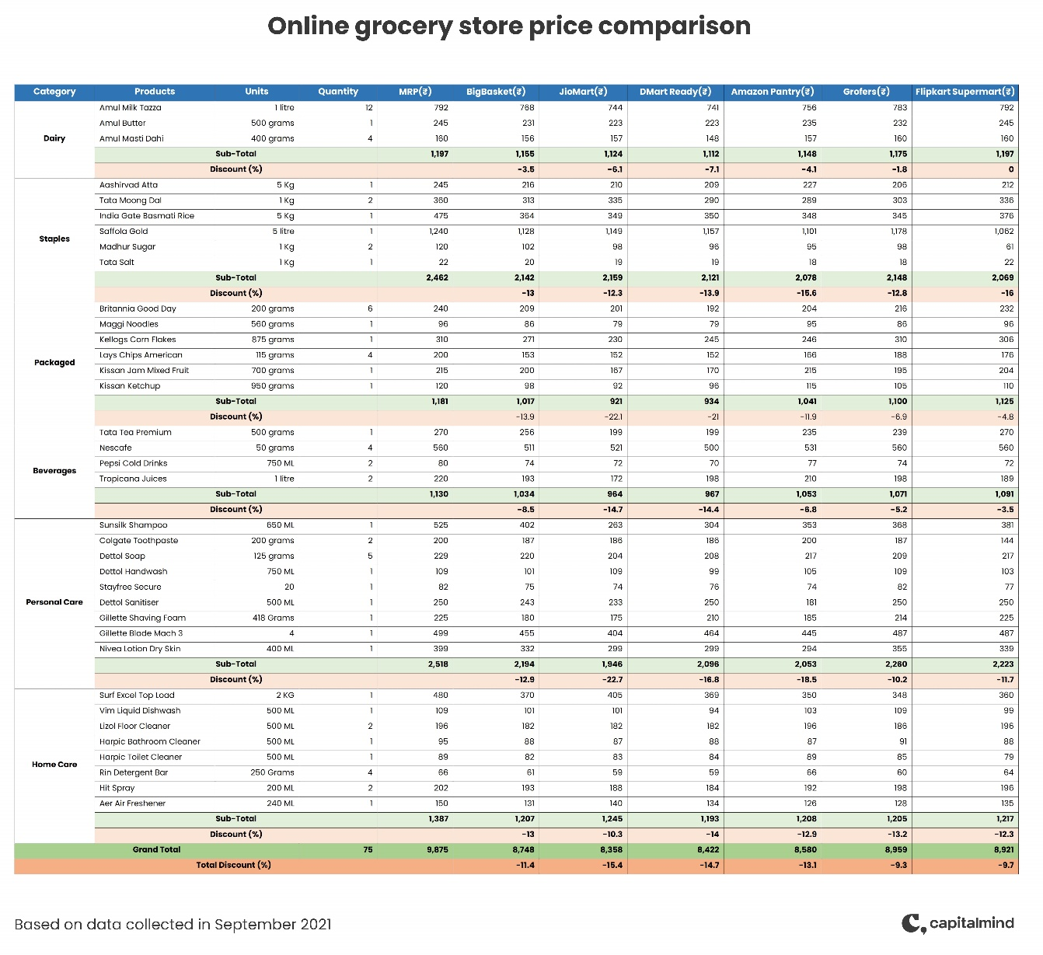

**4.1 Performances Chart**

**8. CONCLUSIONS**

**8.1 Conclusions**

The first conclusion this study provides is the realization of online grocery shopping in Portugal as being a niche market. Although being generally well accepted throughout the world as a form of grocery shopping, with a retail business growing each year, (e.g. Lim, Widdows & Hooker, 2009; Hand, Riley, Harris, Singh & Rettie, 2009), during the execution of the methodology much difficulty was found in reaching actual online grocery shoppers, as the low survey response rate demonstrated. The latter could possibly be due to the general lack of interest of the targeted respondents on the study, the inappropriate method of survey distribution, or the actual low number of online grocery shoppers. Despite the publically announced high number of consumer registrations to the two main online grocery stores (Acepi, 2011), which can be assumed as revealing consumers’ intentions to try out or search more information related to this type of purchase, no official numbers of actual purchases were found in the market and the estimate for Continente Online presented in this study (LINI, 2010; Dionísio, Pereira & Cardoso, 2012) was found to be far lower from the announced number of registered clients. Furthermore, from the sample that was possible of being collected, almost 60% of shoppers claim to shop online for groceries less than once a month. Moreover, all consumers from the sample collected declared shopping for groceries in other traditional stores and showed high levels of aversion towards the purchase of several product categories. Given these facts and the ad-hoc consumer information collected during the process of this study, it can be suggested that online grocery shopping in Portugal is still a developing market facing several market penetrating issues. Nonetheless, through the elaboration of this research, it was possible to gather information regarding the overall decision making process of online grocery shoppers, which, as mentioned, has seldom been the focus of previous research. In general, results revealed high levels of similarities between consumers, which is congruent with a small 47 niche market. Moreover, regarding pre-decisional factors, and although results cannot be generalized, both studies uncovered similar results for the average shopper planning patterns, which further reinforces the previous point. As per the overall decision making process, this was generally found to be a rational process with utilitarian motivations, following defined planning and purchasing patterns established from previous shopping trips. Furthermore, the study of consumer shopping orientations allowed for the definition of different consumer groups, based on the main orientations framing online grocery shopping (e.g., Morganosky & Cude, 2000; Ramus & Nielsen, 2005; Verhoef & Langerak, 2001; POPAI, 2011) – price-sensitivity and convenience. Consumer types within which, it was possible to analyse different decision making variables, according to the defined research questions, leading to the conclusion of the existence of different browsing and purchasing strategies. Two main strategies were found to exist, which vary essentially in the difference between the level of convenience and price-sensitivity orientations. Consumers, who declared a higher degree of price-sensitivity over convenience, showed a more price focused strategy (type A1 consumers). While, consumers who declared a higher degree of convenience over price-sensitivity orientations presented a higher degree of focus towards task completion, rather than price. Two types of consumers were included in this last group, one type of consumers showing high price-sensitivity and high convenience orientations (type A2 consumers), and another group declaring also high convenience, but low price-sensitivity scores (type B consumers). In this sense, what distinguishes type A2 from type B consumers is the different level of price orientation (e.g. deal proneness, price comparisons), while remaining similar through the crucial focus on convenience. However, through consumer observation, it was uncovered that other consumer orientations (i.e. brand and quality orientations) might also be affecting the way consumers shop online for groceries, more specifically affecting product choice and product comparisons made. These new found orientations seem to affect mostly type A2 and B consumers; however, this observation deserves further research. By further analysing all consumer types found, it is also suggested that overall online grocery shoppers present negative responses to all types of in-store stimuli. The analysis revealed low levels of attention and willingness to process advertising and in-store promotional activity, low levels of experimental browsing and low levels of unplanned purchases. In addition, consumers showed some concerns regarding the store’s web connectivity and overall design. Thus, it is important, especially from the retailers’ perspective, to notice the results of 48 consumers’ evaluations and feedback. Most consumers showed satisfaction with their shopping trip and with some aspects of the online store (such as, product variety and delivery service). However, most consumers also expressed their unpleasantness regarding connectivity and page loading – several complained about the excessive waste of time derived from these issues, and some also forgone purchases due to them. Moreover, most consumers declared disliking the way in which the information is organized and presented within the online store, expressing some product search issues as well – once again, some consumers ended up forgoing purchases due to the failure of product search results. Finally, while showing depreciation towards product advertising while shopping, most consumers showed some degree of dissatisfaction regarding the level of product promotions and discounts. Given all the feedback collected, and through the analysis of both the retailers online store and other online grocery stores (national and international stores), it’s fair to say that online grocery stores in Portugal still have some way to go before locking in consumers’ loyalty, satisfaction and frequent repeated purchases.

**REFERENCES**

Here are some references that may be helpful when designing and developing a grocery website:

1. "UX Design for Grocery Shopping Websites" by Nick Babich - This article provides insights into the design principles for creating effective grocery websites, including the importance of usability, simplicity, and visual appeal.

2. "The Ultimate Guide to E-commerce Website Design" by HubSpot - This comprehensive guide provides a step-by-step process for designing an effective e-commerce website, including best practices for navigation, product pages, and checkout processes.

3. "10 Tips for a Successful Online Grocery Store" by Forbes - This article provides practical tips for creating a successful online grocery store, including the importance of mobile optimization, product variety, and customer service.

4. "10 Best Practices for E-commerce User Experience Design" by Smashing Magazine - This article provides a list of best practices for designing an effective e-commerce user experience, including the importance of clear calls-to-action, streamlined checkout processes, and responsive design.

5. "Web Content Accessibility Guidelines (WCAG) 2.1" by W3C - This website provides a comprehensive set of guidelines for designing accessible websites that are usable by people with disabilities.

6. "Google PageSpeed Insights" - This tool by Google provides a comprehensive analysis of a website's performance, including loading time and optimization recommendations.

7. "Google Analytics" - This tool by Google provides website owners with data on website traffic, user behavior, and other metrics that can help improve website design and performance.